Blechexpo press folder 2017, October 2017
Press release 2

The new AMADA FLW ENSIS laser welding cell
New dimensions in laser welding
Equipped with the optimized ENSIS beam technology, the new AMADA FLW ENSIS laser welding cell bridges even large gap sizes. Welding nearly without any deposits and at an exceptional speed, it is entering a new era in laser welding.

The latest development in AMADA's FLW series, the new FLW ENSIS laser welding cell, processes far larger gap sizes than generally possible by using laser welding technology. The system is based on the proven 3-kW fiber laser with variable beam control and the innovative weaving technology whose integrated rotating optics allow the laser beam to move from side to side. In the FLW ENSIS, this AMADA system has once again been optimized. With the so-called “Ring Mode Beam” the welding beam fans out in a ring shape, which allows to optimally bridge even large gap sizes – all this in combination with the weaving technology and the push pull filler wire guide.
No deposits, deformation or discoloration
Another highlight of the new FLW ENSIS laser welding cell lies in the fact that actually no deposits, deformations or discolorations are visible on the lower surfaces of even thin sheet metal. This outstanding quality feature results from the precisely defined energy penetration of the fiber laser, whose strength and range in the welding process can be accurately adjusted – always precisely adapted to the material of the component that is to be processed.
Welding in record time
What is more, the FLW ENSIS excels through its exceptional welding speed which is generally significantly faster than at conventional laser welding systems. The FLW ENSIS welds different materials together in just half the time taken by conventional approaches. An example in this context is manufacturing housings where it’s necessary to weld the outer edges and apply metal plates to reinforce the back of the component.
When it comes to overlap welding operations, the FLW ENSIS is again noticeably faster than conventional techniques and only takes a fraction of the time required to complete the entire welding process. The welds that are applied during this process are at least as durable and resilient as joins produced using spot welding. However, the FLW ENSIS also excels in the field of butt-welding or flux-cored welding, during which it is even possible to switch between welding with and without filler wire without interrupting operation. Last but not least, the M5 version of the machine comes with a shuttle table system, that greatly reduces cycle and stoppage times.

approx. 2,600 characters

Technical data FLW-3000ENSIS M5
Laser | AMADA fiber laser with variable beam adjustment
Laser output | 3000 W
Robot | 6-axis industrial robot
Linear robot track | 4000 mm
Equipment | Two rotary tilting tables, which can be moved as a shuttle table system
Special feature | Protective cabin of the highest safety category to allow low-personnel operation

Illustration

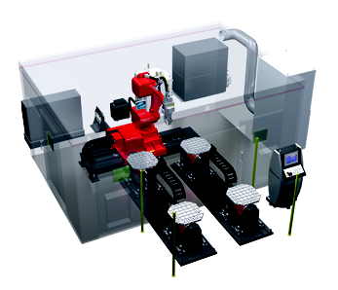 | The FLW-3000ENSIS M5 welding cell is the ideal solution for bridging especially large gap sizes.
Source: AMADA GmbH

For further information:

AMADA GmbH
Amada Allee 1
42781 Haan - Germany

Press contact: Nicole Goldhorn

Phone: +49 2104 2126-0
E-mail: nicole.goldhorn@amada.de

www.amada.de
Please provide specimen copy if reproduced

